Screenshot 1:

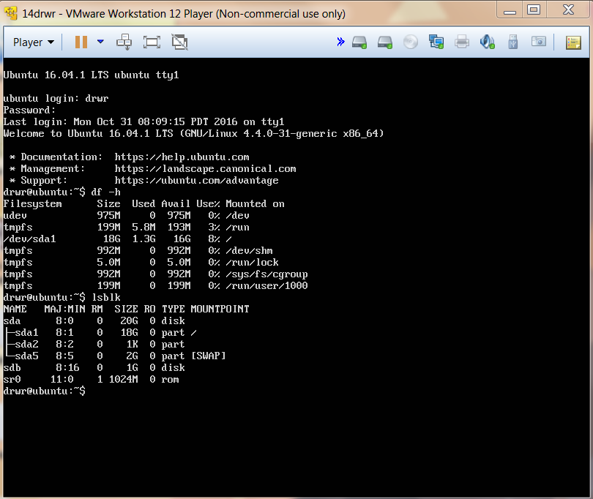

The “lsblk” command showed the new hard disk named “sdb” with a size of 1GB.

Screenshot 2:

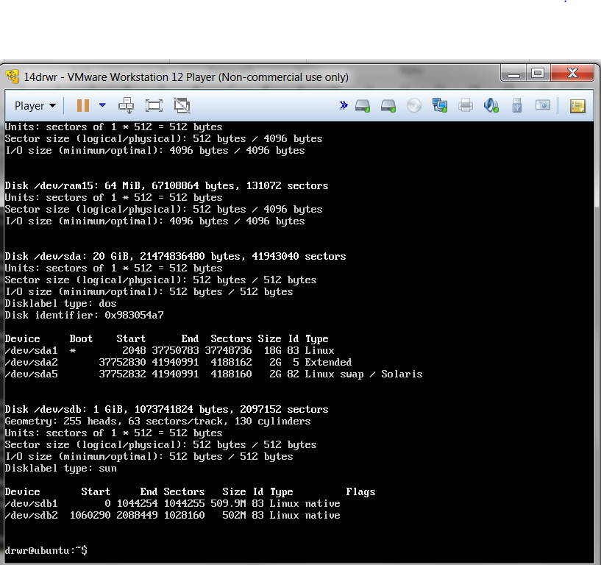

Screenshot 3:

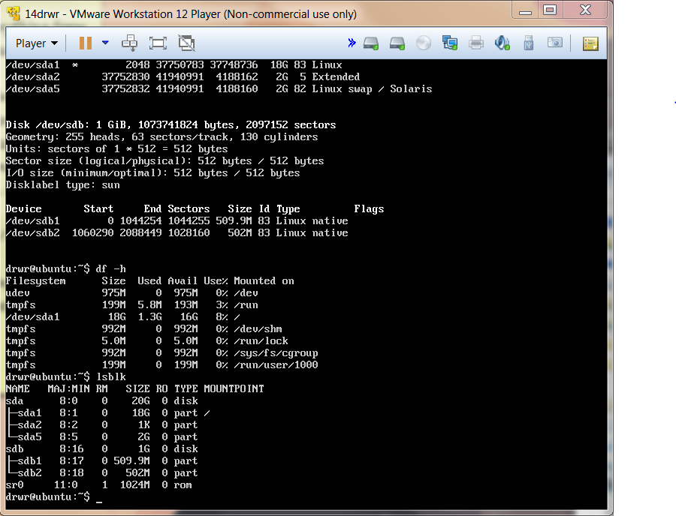

Once again, lsblk shows the new hard disk “sdb” with a size of 1GB as well as sdb1 and sdb2.

Screenshot 4:

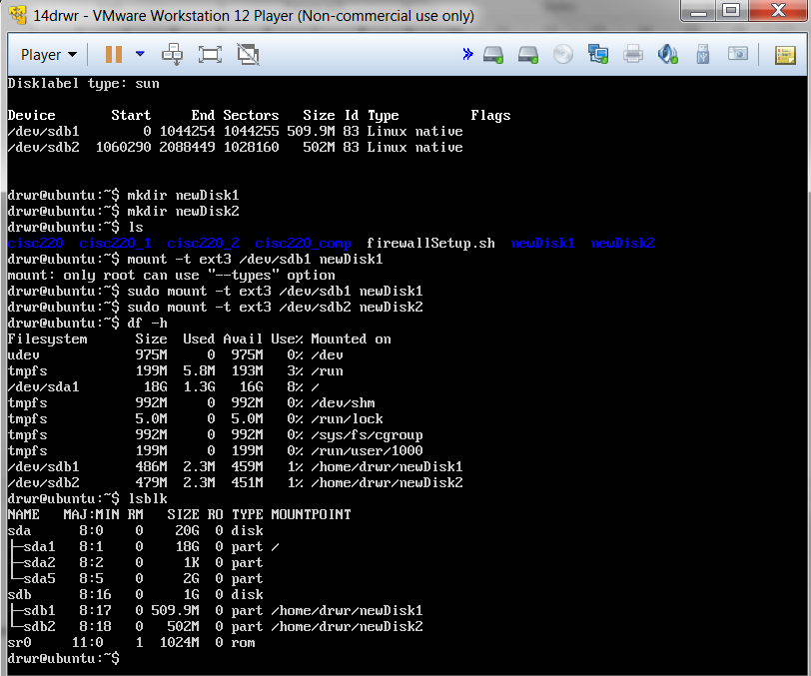

This time, the two new partitions (/dev/sdb1, /dev/sdb2) can been seen under the output of “df –h” as well.